**Assignment 8.1**

**Question:** Write a mapreduce program to find the total amount of petrol in volume sold by every distributor.

***Driver***

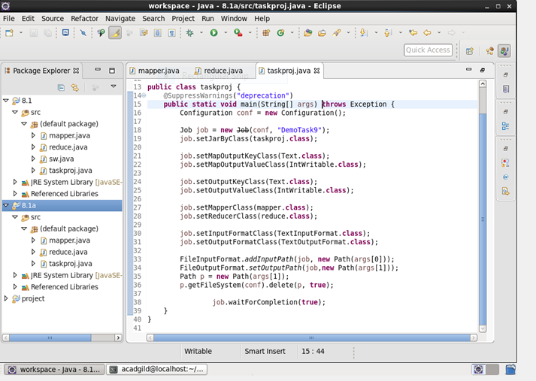

***Mapper***

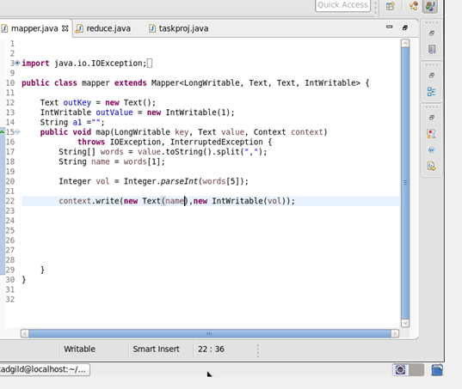

***Reducer*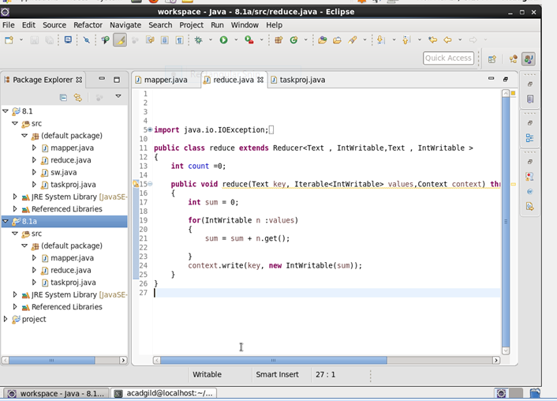**

**Output**

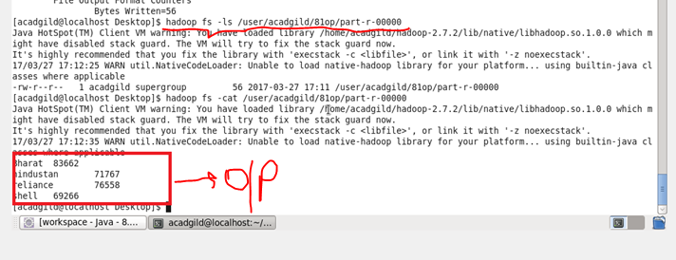

**Question:** Write a mapreduce program to find which are the top 10 distributors ID's for selling petrol and also display the amount of petrol sold in volume.

***Driver***

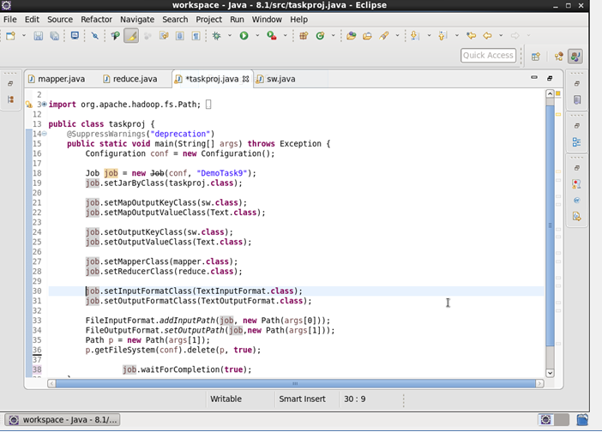

***Mapper***

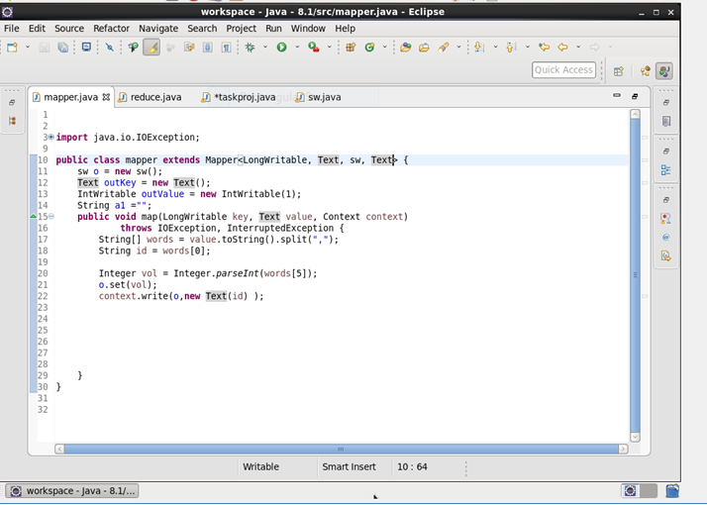

***Reducer***

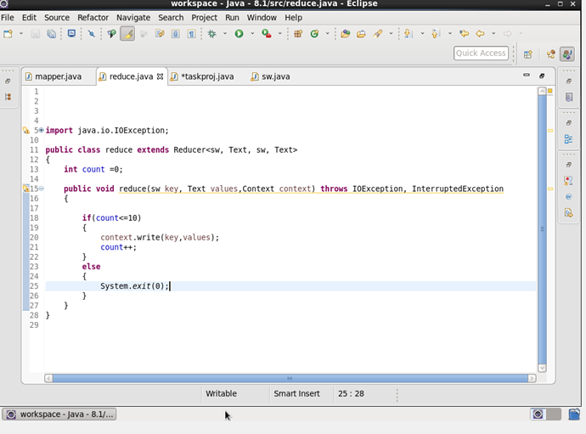

***Custom writable***

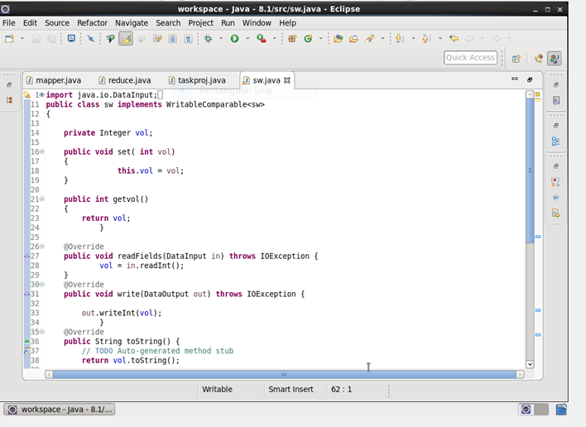

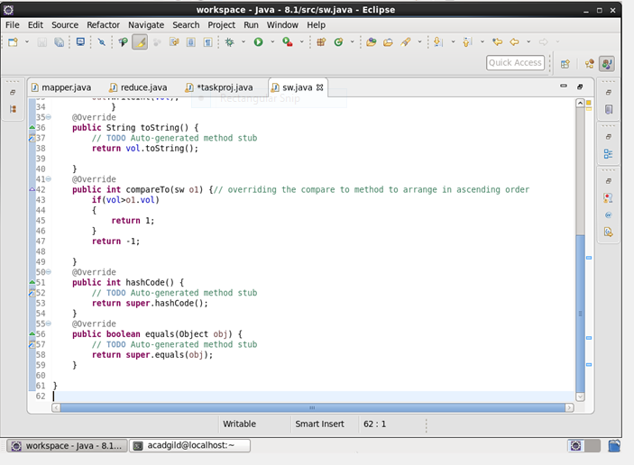

**Output**

